**Postgres 9 installation for the OPUS development environment in Windows 7 Professional**

This guide shows the steps to install the Postgres 9 database on Windows 7 Professional.

The latest available version of the Postgres 9 is recommended and used in this guide.

Date: 12. November 2014

# Install Postgres 9

Installation file: postgresql-9.3.5-3-windows.exe

Follow the wizard:

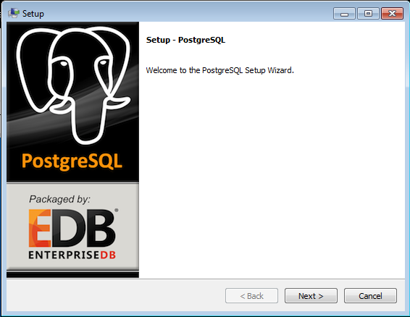

The default paths are fine:

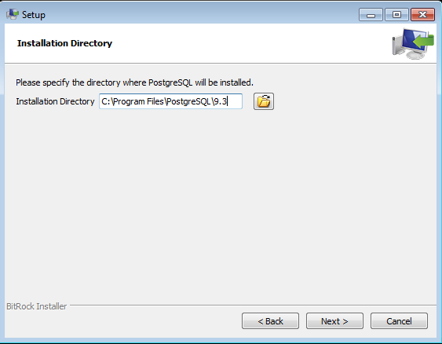

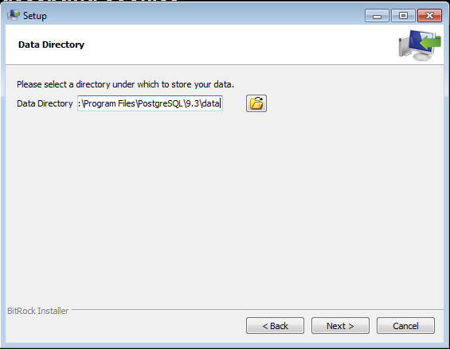

Specify the password (e.g. „123koffie“) and do not forget this password:

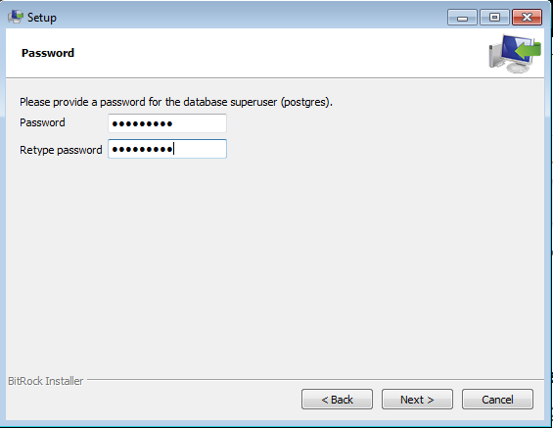

The default port is fine:

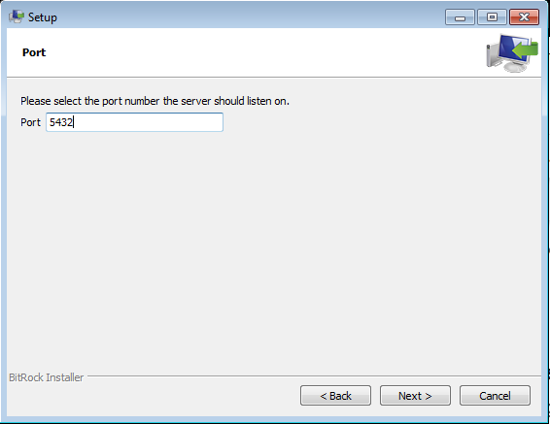

Default locale is fine:

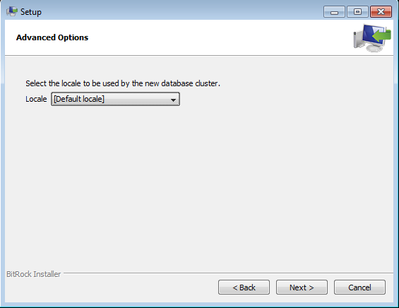

Setup is now ready to install:

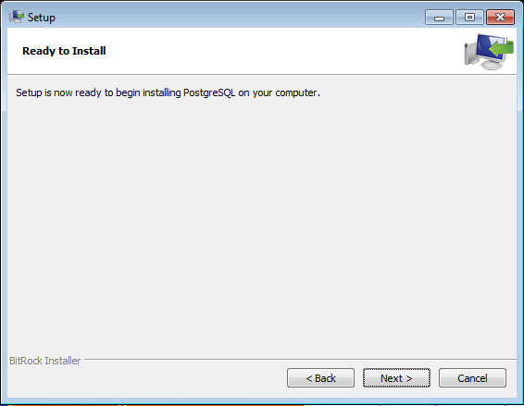

Disable the StackBuilder:

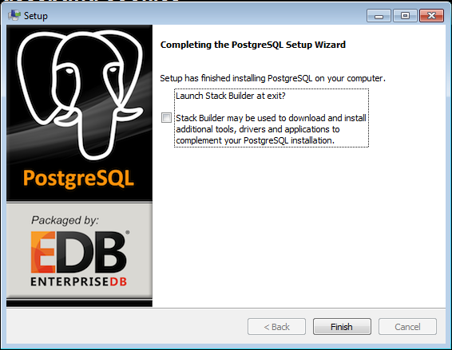

The installation is now finished.

To verify the installation, open the pgAdmin from the Windows Start menu:

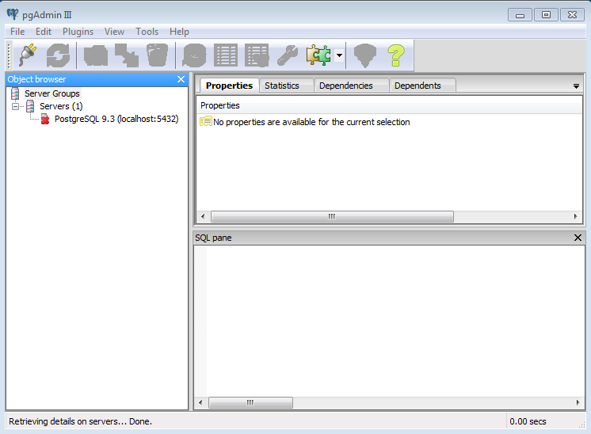

Double click on „PostgreSQL 9.3 (localhost:5432) and enter the password, select „Store password“, and click OK:

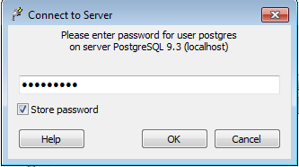

A warning about storing passwords shows up. Select „Do not show this hint again“ and click OK:

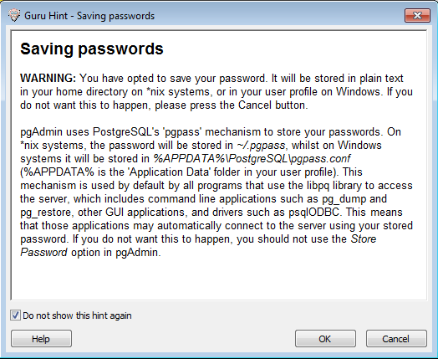

The screen shows a successful connection to the Postgres database server:

